**TABLE OF CONTENTS Page**

1. ABSTRACT 1

2. REFERENCES 2

3. METHODS AND SETUP 2

4. RESULTS 5

5. CONCLUSION 9

6. ATTachments 10

# ABSTRACT

The purpose of this study is to provide objective evidence that the MEGADYNE ACE BLADE 700 Soft Tissue Dissector ZIP-PENTM Smoke Evacuation Pencil satisfies defined customer requirements when used within actual or simulated-use environments in a manner consistent with the Package Insert. This study will focus on the surgeon experience with the device. The ZIP-PENTM Smoke Evacuation Pencil (15 foot cord length) and 2330 Filter, In-Line, ULPA, w/ regulator tube set may also be evaluated permitted sufficient user availability.

Table 1 list the applicable requirements per product to be validated in this study. Questions 1, 2, 4, 12 and 13 are required to validate product code 2330. Questions 3 – 9 are required to validate ACE 700 product codes ME7251C, ME7251E, ME725M1C, ME725M1E. Questions 3-11 are required to validate ZIP-PEN product codes 252510 (2525-10), 252510EC (2525-10EC), 252515 (2525-15), 252515EC (252515-EC), 252510BN (2525-10BN), 252510ECBN (2525-10ECBN). The catalog numbers in parentheses are identical from a product perspective. The numbers with a hyphen are from the historical Megadyne Medical Products system whereas without a hyphen are for the Ethicon system.

NOTE: The protocol was ink signed prior to the start of this study and the necessary functional signatures were obtained per QA-SOP-013 in lieu of obtaining electronic signatures through MasterControl. The scanned images of the ink signatures are included in the electronic file within MasterControl.

**Table 1: Products and applicable requirements**

|  | **Validation Question** | **2330 Filter** | **ACE 700** | **ZIP 15** |
| --- | --- | --- | --- | --- |
| 1 | Rate the ability to connect the In-Line filter to the wall and suction canister | X |  |  |
| 2 | Rate the ability to connect the Zip-pen to the suction canister | X |  |  |
| 12 | Rate the ability to disconnect the In-Line filter to the wall and suction canister | X |  |  |
| 13 | Rate the ability to disconnect the Zip-pen to the suction canister | X |  |  |
| 3 | Did the device monopolar functionality perform as expected |  | X | X |
| 4 | Rate the ability to evacuate smoke away from the surgical site | X | X | X |
| 5 | Rate the ability to visualize the active electrode during the procedure |  | X | X |
| 6 | Rate the ergonomics of the device |  | X | X |
| 7 | Rate the amount of drag on your hand from the tubing |  | X | X |
| 8 | Rate the tactile feel of the buttons |  | X | X |
| 9 | Rate the security of the active electrode when cleaning |  | X | X |
| 10 | Rate the ability to remove the active electrode |  |  | X |
| 11 | Rate the ability to insert the active electrode into the collet |  |  | X |

# REFERENCES

|  |  |
| --- | --- |
| ENG-PRT-453 | Design Validation Study with Surgeons, ACE BLADE 700 and Zip Pen |
| MKT-CMR-029 | CMR Smoke Evacuation Product Line |
| MKT-CMR-023 | ACE Blade Product Portfolio |
| ENG-PS-007 | Smoke Evacuation and Accessories Product Spec |
| MKT-US-002 | Usability Specification – Smoke Evacuation Pencils and Universal ULPA Filter |

# METHODS AND SETUP

This evaluation was performed as a “piggy-back” to project Hurricane (Cincinnati) Usability Study conducted in Houston Texas at the Houston Methodist Institute for Technology, Innovation & Education (MITIESM) on November 29, 2017 – December 1, 2017. The project Hurricane study involved the evaluation of a laparoscopic harmonic device in a porcine model that was set up for laparoscopic procedures. The Megadyne portion of this study is for an open device and therefore the Megadyne set-up was on a side table in ex-vivo tissue (beef tri-tip roast) inside a surgical trainer. Matt Miller facilitated the evaluation of the Surgeons and Nurse representatives and a training record can be found in Attachment 2 of this report. The Surgeon information was captured as part of the project Hurricane study and is included in Table 2.

**Table 2: Surgeon information**

|  | Surgeon 1 | Surgeon 2 | Surgeon 3 | Surgeon 4 |
| --- | --- | --- | --- | --- |
| City | Houston | Houston | Houston | Houston |
| Date | 29-Nov | 30-Nov | 30-Nov | 1-Dec |
| Gender | Male | Male | Female | Male |
| Specialty | Bariatric | Bariatric | GYN | Colorectal |
| Glove size | 7.5 | 7.5 | 6.5 | 7 |
| Years in practice | 15-19 | 20-24 | 15-19 | 15-19 |
| # Procedures/month | 50-60 | 12-15 | 8-16 | 40-50 |
| % procedures Lap | 45% | 90% | 75% | 90% |

Table 3 lists the products that were used during the evaluation

**Table 3: Products used during the evaluation**

|  |  |  |
| --- | --- | --- |
| **Megadyne Catalog #** | **Description** | **Lot #** |
| ME7251E | MEGADYNE ACE BLADE 700 Soft Tissue Dissector ZIP-PENTM Smoke Evacuation Pencil | 5170326 |
| 0855C | Electrosurgical Patient Return Electrode | S140446 |
| 1000 | MegaPower generator (1000) | SN: 172427001 |
| 2330 | In-Line ULPA Filter | 175730 |
| 2145 | 22mm Male to 10mm Male connector | 174369 |
| N/A | Bemis Hi-Flow 1200cc Suction Canister | N/A |
| N/A | Surgical Trainer | N/A |

## **Nurse Representative**

The first task for the Nurse representative that was performed was set-up of the In-Line ULPA Filter (2330) to Operating Room Vacuum and a Suction Canister. Set-up for this step is shown in Figure 1. The nurse representative was shown the draft IFU for the 2330 In-Line ULPA filter (See ENG-PRT-453 Attachment 2) prior to connecting the filter.

**Figure 1 Set-up of 2330 In-Line ULPA filter**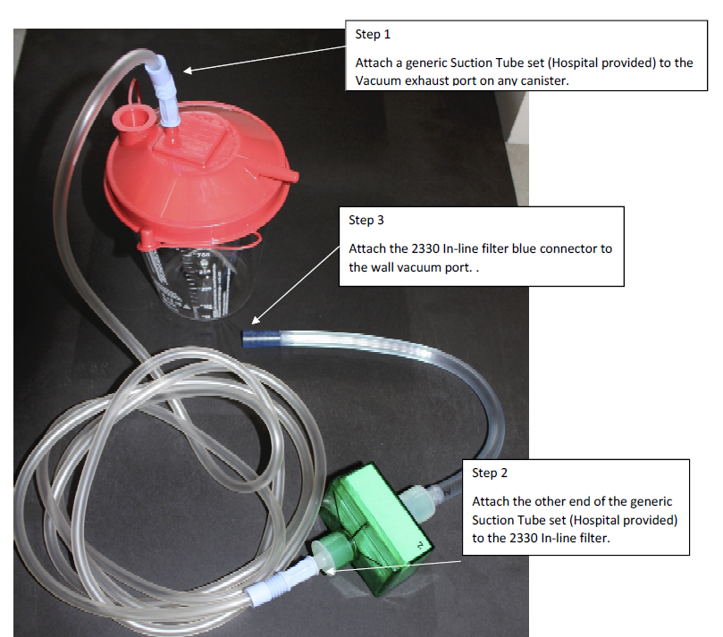

The second task for the Nurse representative that was performed was set-up of the ACE BLADE 700 to the suction canister using a 2145 connector as shown in Figure 2.

**Figure 2 Set up of ACE BLADE 700 to Suction Canister**

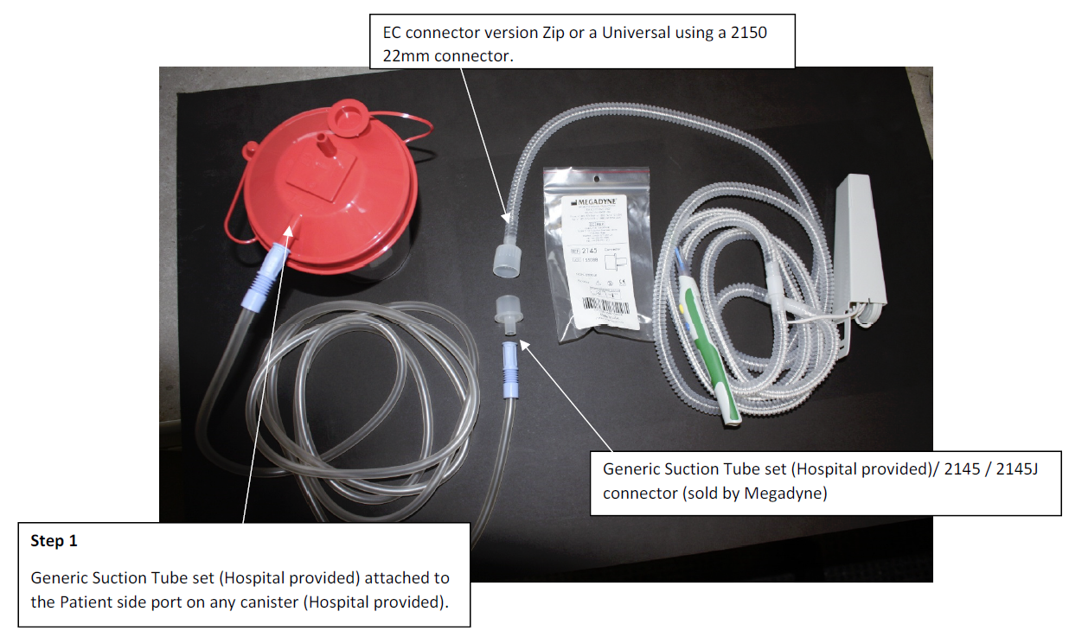

The final task for the Nurse representative that was performed was to disconnect the 2330 In-Line ULPA filter and the ACE BLADE 700 from the Suction canister and OR Vacuum as if they were preparing for disposal.

These tasks were performed by the MITIE veterinary technicians, who are deemed as an acceptable Circulating Nurse representatives, as they routinely set up suction and instrumentation in a OR setting to perform surgical procedures on porcine animate models.

After all tasks were completed, each nurse representative was asked the following validation questions:

* Rate the ability to connect the In-Line filter to the wall and suction canister
* Rate the ability to connect the Zip-pen to the suction canister
* Rate the ability to disconnect the In-Line filter to the wall and suction canister
* Rate the ability to disconnect the Zip-pen to the suction canister

## **Surgeon**

The surgical trainer (See figure 3) was set-up with a beef roast purchased at a local grocery store with a 0855C Electrosurgical Patient Return Electrode attached to the bottom side of the roast. A small Weitlaner Retractor was place in the incision in the synthetic skin to hold the incision open. This was set up prior to the Surgeon tasks.

**Figure 3 Surgical Trainer**

|  |  |
| --- | --- |
|  |  |

The surgeon was shown the ACE BLADE 700 and the different configurations of the ZIP-PEN tubing was demonstrated by the moderator. The Surgeon was asked to use the most comfortable configuration of the ZIP-PEN tubing. The Surgeon was then asked to use the cut and coagulate functions of the device on the beef roast tissue. At this time the OR vacuum was turned off so that the surgical smoke generated by the activity would start to build inside the trainer. The OR vacuum was turned on and the surgeon continued to use the device on the tissue. The Surgeon was then asked to use a 4x4 lap sponge to clean the active electrode of the ACE BLADE 700 device.

After all tasks were completed, each Surgeon was asked the following validation questions:

* Did the device monopolar functionality perform as expected?
* Rate the ability to evacuate smoke away from the surgical site
* Rate the ability to visualize the active electrode during the procedure
* Rate the ergonomics of the device
* Rate the amount of drag on your hand from the tubing
* Rate the tactile feel of the buttons
* Rate the security of the active electrode when cleaning

# RESULTS

## **Nurse Representative**

The first participant only performed and evaluated the setup of the device (questions 1 and 2) as the disconnection and removal steps later in the day after the surgeon evaluation had taken place. The first participant had already left and could not be located the remainder of the lab. As a result, the other 3 participants were asked to perform the entire setup and disposal evaluation at one time to ensure complete evaluations were conducted.

**Validation Question 1 - Rate the ability to connect the In-Line filter to the wall and suction canister**

Summary: All four participants rated the ability to connect the In-Line filter to the wall and suction canister as acceptable.

Detailed Responses:

|  |  |  |  |
| --- | --- | --- | --- |
| **Participant** | **Acceptable** | **Acceptable w/Comments** | **Unacceptable** |
| 1 | X |  |  |
| 2 | X |  |  |
| 3 | X |  |  |
| 4 | X |  |  |
| **TOTAL** | **4** | **0** | **0** |

**Validation Question 2 - Rate the ability to connect the Zip-pen to the suction canister**

Summary: All four participants rated the ability to connect the Zip-pen to the suction canister as acceptable.

Detailed Responses:

|  |  |  |  |
| --- | --- | --- | --- |
| **Participant** | **Acceptable** | **Acceptable w/Comments** | **Unacceptable** |
| 1 | X |  |  |
| 2 | X |  |  |
| 3 | X |  |  |
| 4 | X |  |  |
| **TOTAL** | **4** | **0** | **0** |

**Validation Question 12 - Rate the ability to disconnect the In-Line filter to the wall and suction canister**

Summary: Three of Four participants rated the ability to disconnect the In-Line filter to the wall and suction canister as acceptable.

Detailed Responses:

|  |  |  |  |
| --- | --- | --- | --- |
| **Participant** | **Acceptable** | **Acceptable w/Comments** | **Unacceptable** |
| 1 | did not perform task | | |
| 2 | X |  |  |
| 3 | X |  |  |
| 4 | X |  |  |
| **TOTAL** | **3** | **0** | **0** |

**Validation Question 13 - Rate the ability to disconnect the Zip-pen to the suction canister**

Summary: Three of Four participants rated the ability to disconnect the Zip-pen to the suction canister as acceptable. Detailed Responses:

|  |  |  |  |
| --- | --- | --- | --- |
| **Participant** | **Acceptable** | **Acceptable w/Comments** | **Unacceptable** |
| 1 | did not perform task | | |
| 2 | X |  |  |
| 3 | X |  |  |
| 4 | X |  |  |
| **TOTAL** | **3** | **0** | **0** |

## **Surgeon**

**Validation Question 3 - Did the device monopolar functionality perform as expected?**

Summary: All four participants rated device monopolar functionality as acceptable.

Detailed Responses:

|  |  |  |  |
| --- | --- | --- | --- |
| **Participant** | **Acceptable** | **Acceptable w/Comments** | **Unacceptable** |
| 1 | X |  |  |
| 2 | X |  |  |
| 3 | X |  |  |
| 4 | X |  |  |
| **TOTAL** | **4** | **0** | **0** |

**Validation Question 3 - Rate** **the ability to evacuate smoke away from the surgical site**

Summary: One participant rated the ability to evacuate smoke away from the surgical site as acceptable. Three participants rated the ability to evacuate smoke away from the surgical site as acceptable with comments. One participant felt that the suction could be a little stronger, but that smoke evacuation performance was better than without it. One participant suggested moving the nozzle closer to the tip for better smoke evacuation. One participant felt that smoke evacuation performance was better than without and that the odor was noticeably less with the smoke evacuation feature.

Detailed Responses:

|  |  |  |  |
| --- | --- | --- | --- |
| **Participant** | **Acceptable** | **Acceptable w/Comments** | **Unacceptable** |
| 1 | X |  |  |
| 2 |  | X - Annoyance - could use a little stronger, but better than without it |  |
| 3 |  | X - Annoyance - improve by nozzle closer to tip |  |
| 4 |  | X - Better than not having, 7 out 10, odor is less |  |
| **TOTAL** | **1** | **3** | **0** |

**Validation Question 5 - Rate the ability to visualize the active electrode during the procedure**

Summary: All four participants rated the ability to visualize the active electrode during the procedure as acceptable

Detailed Responses:

|  |  |  |  |
| --- | --- | --- | --- |
| **Participant** | **Acceptable** | **Acceptable w/Comments** | **Unacceptable** |
| 1 | X |  |  |
| 2 | X |  |  |
| 3 | X |  |  |
| 4 | X |  |  |
| **TOTAL** | **4** | **0** | **0** |

**Validation Question 6 - Rate the ergonomics of the device**

Summary: Three participants rated the ergonomics of the device as acceptable. One participant the ergonomics of the device as acceptable with comments that the device felt heavy based on the drag from the hose.

Detailed Responses:

|  |  |  |  |
| --- | --- | --- | --- |
| **Participant** | **Acceptable** | **Acceptable w/Comments** | **Unacceptable** |
| 1 | X |  |  |
| 2 | X |  |  |
| 3 | X |  |  |
| 4 |  | X - Heavy, Drag from hose |  |
| **TOTAL** | **3** | **1** | **0** |

**Validation Question 7 - Rate the amount of drag on your hand from the tubing**

Summary: Two participants rated the amount of drag on your hand from the tubing as acceptable. Two participants rated the amount of drag on your hand from the tubing as acceptable with comments. One participant commented that the trigger method configuration was excellent but that the traditional configuration had a little more drag. One participant felt that the drag in the traditional configuration was almost unacceptable for the fine movements required during surgical breast augmentation however utilized the trigger method during the evaluation. This was classified by the surgeon as a usability related vs a safety hazard. A review of the ZIP-PEN complaint analysis (see ENG-RMF-045) shows there are no complaints related to the usability of the device. A line item has been added to the application section of ENG-RMF-045 (62-a) to document this item and the risk level is acceptable.

Detailed Responses:

|  |  |  |  |
| --- | --- | --- | --- |
| **Participant** | **Acceptable** | **Acceptable w/Comments** | **Unacceptable** |
| 1 | X |  |  |
| 2 | X |  |  |
| 3 |  | X - Annoyance - trigger method is excellent, traditional has a little more drag |  |
| 4 |  | X - almost unacceptable, heavy drag |  |
| **TOTAL** | **2** | **2** | **0** |

**Validation Question 8 - Rate the tactile feel of the buttons**

Summary: All four participants rated the tactile feel of the buttons as acceptable.

Detailed Responses:

|  |  |  |  |
| --- | --- | --- | --- |
| **Participant** | **Acceptable** | **Acceptable w/Comments** | **Unacceptable** |
| 1 | X |  |  |
| 2 | X |  |  |
| 3 | X |  |  |
| 4 | X |  |  |
| **TOTAL** | **4** | **0** | **0** |

**Validation Question 9 - Rate the security of the active electrode when cleaning**

Summary: All four participants rated the security of the active electrode when cleaning as acceptable.

Detailed Responses:

|  |  |  |  |
| --- | --- | --- | --- |
| **Participant** | **Acceptable** | **Acceptable w/Comments** | **Unacceptable** |
| 1 | X |  |  |
| 2 | X |  |  |
| 3 | X |  |  |
| 4 | X |  |  |
| **TOTAL** | **4** | **0** | **0** |

**Validation Question 10 - Rate the ability to remove the active electrode**

This question was not asked as a scrub nurse or equivalent was not available at this research location.

**Validation Question 11 - Rate the ability to insert the active electrode into the collet**

This question was not asked as a scrub nurse or equivalent was not available at this research location.

# CONCLUSION

A minimum of 3 individuals evaluated the devices which satisfies the requirements of the protocol.

The questions required to validate product code 2330 (Questions 1, 2, 4, 12 and 13 from table 1) all received ratings of “Acceptable and therefore satisfy the acceptance criteria for this study.

The questions required to validate ACE 700 product codes ME7251C, ME7251E, ME725M1C, ME725M1E. (Questions 3-9 from table 1) all received ratings of “Acceptable” and “Acceptable with Comments” (where comment was acceptably clarified) and are considered to satisfy the acceptance criteria for this study. There were no ratings of unacceptable or where a patient safety risk was identified within the surgeon’s comments.

The questions required to validate ZIP-PEN product codes 252510, 252510EC, 252515, 252515EC, 252510BN, 252510EC. (Questions 3-9 from table 1) all received ratings of “Acceptable” and “Acceptable with Comments” (where comment was acceptably clarified) and are considered to satisfy the acceptance criteria for this study. There were no ratings of unacceptable or where a patient safety risk was identified within the surgeon’s comments. Questions 10 and 11 will be evaluated in a separate study (ENG-PRT-452) which will be conducted with scrub nurses since scrub nurses or their equivalents were unavailable during this research. Completion of both ENG-PRT-453 and ENG-PRT-452 is required to validate these ZIP-PEN product codes. Although the 15 ft version of the ZIP-PEN was not used during this study, everything (except tubing and cord length) are the same between the 15 ft and 10 ft versions. Given this could potentially affect the suction capability, results from flow rate testing in ENG-PRT-329 were reviewed and support there is no practical difference between the flow rate (suction capability) between the 15 ft and 10 ft versions of the ZIP-PEN. Therefore the 15 ft version is validated based on the validation results using ME7251E (which is a 10 ft ZIP-PEN with an ACE blade).

# ATTachments

## Attachment 1 - Moderator notes

## Attachment 2 - Training Record